ARC (Audio Resource Companion)

Ryan Kildea

University of Missouri – Kansas City

Table of Contents

Vision Statement 3

Requirements 4

Product Backlog 5

Sprint #1 6

Review 6

Retrospective 6

Sprint #2 7

Review 7

Retrospective 7

Sprint #3 8

Review 8

Retrospective 8

Sprint #4 9

Review 9

Retrospective 9

Sprint #5 10

Review 10

Retrospective 10

Sprint #6 11

Review 11

Retrospective 11

# **Vision Statement**

Audio Resource Companion (ARC) is a music application for Android operating systems. The program will allow users to import their collection of music files for playback. ARC will pull artist information from these files and, using an undetermined API, provide the users with a backlog of the most recent albums released by all artists found in their library. Stretch goals for ARC involve features that are often not highlighted in traditional media players. In time, ARC will identify songs from the user’s collection and use APIs in order to retrieve lyrics for the current song, album artwork, and links to music videos.

# **Requirements**

A discussion of what your application is required to have in functionality. It should identify user roles and goals/actions, and what the key features of the app should be.

|  |  |
| --- | --- |
| **Actor** | **Goal** |
| User | Provide an interface for easy navigation between the library, artist lists, album lists, and song lists. |
|  | Feature for importing music from the user device into the library. |
|  | Audio playback functionality; play, pause, rewind, fast forward, skip, repeat, randomize. |
|  | Presentation and, if applicable, editing of audio file tags, including artist, album, song title, running length, release date, lyrics, etc. |
|  | (For recently released albums feature) An API is needed that requests access to the backlog of all albums released by a given artist for all artists in the user library. |
|  | (For lyric look-up functionality) An API is needed that requests lyrics for a given song |
|  | (For music video functionality) An API that receives information on if a music video is available for a given song |

### Product Backlog

This will be updated throughout the semester as new PBIs are added, larger items are broken into smaller ones, and completed items removed.

|  |  |  |  |  |
| --- | --- | --- | --- | --- |
| **Story ID** | **Story** | **Story Points**  **(in est. hours)** | **Priority** | **Status** |
| 12 | The user should see a splash screen upon starting the application | 2 | Low | Complete |
| 1 | The user should be greeted by a home screen | 0.5 | Very high | Complete |
| 2 | The user should have access to a toolbar that allows access to their library | 0.25 | Very high | Complete |
| 3 | The user should be able to import music files into their library; music files should be listed with Artist, Album, Song Title, and Track Length | 6 | Very high | Unfinished |
| 4 | The user should be able to click a song and play that song | 4 | High | Unfinished |
| 5 | The user should have access to audio controls; player volume, play, pause, skip to previous/next track, skip X seconds back/forward, randomize, repeat, view lyrics | 6 | High | Unfinished |
| 6 | The user should be able to swap between different library view modes; “Artists” view, “Albums” view, “Songs” view | 2 | Medium | Unfinished |
| 7 | The user should be able to view the properties of a file in their library | 2 | Low | Unfinished |
| 8 | The user should be able to edit song properties such as artist, album, song title, lyrics, and album artwork | 4 | Low | Unfinished |
| 9 | An API should be implemented to query all of the artists in the users’ library and return a chronological list of latest releases of all their artists | 6 | Very low | Unfinished |
| 10 | An API should be implemented to pull in album artwork for all albums in the users’ library, should the user request it | 3 | Very low | Unfinished |
| 11 | An API should be implemented to pull in lyrics for a user’s song, should the user request it | 3 | Very low | Unfinished |
| 12 | The user should see a splash screen upon starting the application | 2 | Low | Complete |
| 13 | The artist page should display clickable buttons with an artist picture on them | 4 | Low | Complete |

# **Sprint #1**

Sprint Backlog

|  |  |  |  |
| --- | --- | --- | --- |
| **Story ID** | **Story / Task** | **Estimated**  **Hours** | **Actual**  **Hours** |
| 1 | The user should be greeted by a home screen | 0.5 | 1 |
| 2 | The user should have access to a toolbar that allows access to their library | 0.25 | 4 |
| 3 | The user should be able to import music files into their library; music files should be listed with Artist, Album, Song Title, and Track Length | 6 | N/A |
| 4 | The user should be able to click a song and play that song | 3 | N/A |
| 12 | The user should see a splash screen upon starting the application | 2 | 3 |
|  |  |  |  |
|  |  |  |  |

## 

## Review

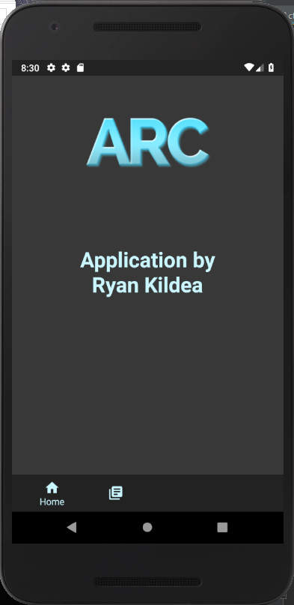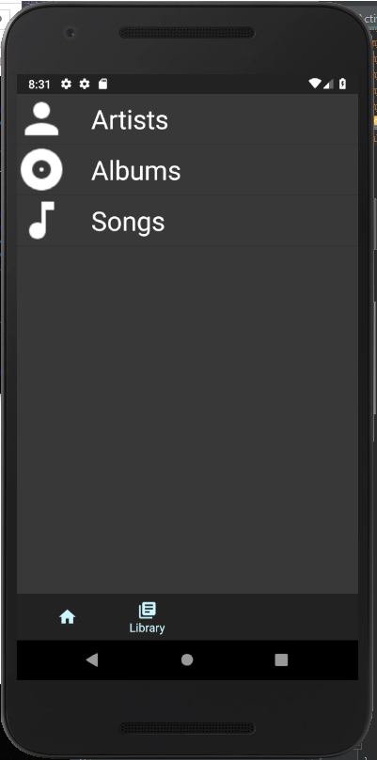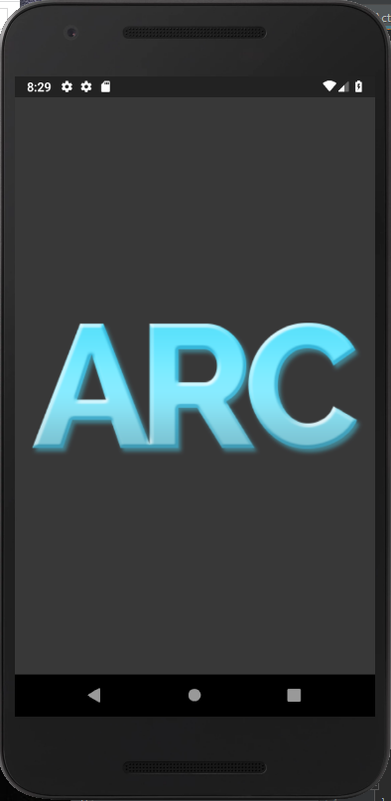

Added during this sprint was the splash screen for the app, a dynamic bottom action bar, the home screen, and the interface for the library. The ability to import files and play songs has not yet been finished.

## Retrospective

I think the process went well in general. The biggest things were first that I overestimated how much could be accomplished while being semi-new to Java and totally new to Android Studio. In the future, I will try to include this into my factoring of time. Also, since this app is not for an organization, I went ahead and completed a low-priority item (the splash screen) because it seemed to help polish the application a bit and will give me consistent results moving forward. I probably should have stuck to my priority plan, but regardless, the feature was completed and I am happy with my application so far.

# **Sprint #2**

Sprint Backlog

|  |  |  |  |
| --- | --- | --- | --- |
| **Story ID** | **Story / Task** | **Estimated**  **Hours** | **Actual**  **Hours** |
| 3 | The user should be able to import music files into their library; music files should be listed with Artist, Album, Song Title, and Track Length | 6 | Not finished |
| 4 | The user should be able to click a song and play that song | 4 | 4 |
| 13 | The artist page should display clickable buttons with an artist picture on them | 4 | 5 |
|  |  |  |  |
|  |  |  |  |
|  |  |  |  |
|  |  |  |  |

## Review

## 

## Retrospective

[This is where you discuss the process. What went well (and are you planning to do more of that?) What didn’t go so well (and do you have a way to do less of that)? What changes are you planning to make in how you plan & carry out the next sprint?]

The things that went really well are that I learned a lot of new features for both Android and Java this sprint and I am starting to feel more comfortable with both. I have constantly been venturing out of my comfort zone while making this app and it is working out and very cool. The things that didn’t go well is that I seem to spend an inordinate amount of time on more trivial details. For example, I did not want the artist icons to show up as solid squares – I wanted rounded ones instead, and figuring out how to do this added many hours to my project. I think the result in the end is worth it, I just don’t think it would be a good idea to do so in a corporate setting. For the next sprint, I hope to stay focused and get done with the key functionalities, instead of focusing on more trivial details.

# **Sprint #3**

Sprint Backlog

|  |  |  |  |
| --- | --- | --- | --- |
| **Story ID** | **Story / Task** | **Estimated**  **Hours** | **Actual**  **Hours** |
|  |  |  |  |
|  |  |  |  |
|  |  |  |  |
|  |  |  |  |
|  |  |  |  |
|  |  |  |  |
|  |  |  |  |

## Review

[Screenshots, etc go here. This is where you discuss the product, describing what was done this sprint (potentially shippable product increment) and what was planned for the sprint but was not done. ]

## Retrospective

[This is where you discuss the process. What went well (and are you planning to do more of that?) What didn’t go so well (and do you have a way to do less of that)? What changes are you planning to make in how you plan & carry out the next sprint?]

# **Sprint #4**

Sprint Backlog

|  |  |  |  |
| --- | --- | --- | --- |
| **Story ID** | **Story / Task** | **Estimated**  **Hours** | **Actual**  **Hours** |
|  |  |  |  |
|  |  |  |  |
|  |  |  |  |
|  |  |  |  |
|  |  |  |  |
|  |  |  |  |
|  |  |  |  |

## Review

[Screenshots, etc go here. This is where you discuss the product, describing what was done this sprint (potentially shippable product increment) and what was planned for the sprint but was not done. ]

## Retrospective

[This is where you discuss the process. What went well (and are you planning to do more of that?) What didn’t go so well (and do you have a way to do less of that)? What changes are you planning to make in how you plan & carry out the next sprint?]

# **Sprint #5**

Sprint Backlog

|  |  |  |  |
| --- | --- | --- | --- |
| **Story ID** | **Story / Task** | **Estimated**  **Hours** | **Actual**  **Hours** |
|  |  |  |  |
|  |  |  |  |
|  |  |  |  |
|  |  |  |  |
|  |  |  |  |
|  |  |  |  |
|  |  |  |  |

## Review

[Screenshots, etc go here. This is where you discuss the product, describing what was done this sprint (potentially shippable product increment) and what was planned for the sprint but was not done. ]

## Retrospective

[This is where you discuss the process. What went well (and are you planning to do more of that?) What didn’t go so well (and do you have a way to do less of that)? What changes are you planning to make in how you plan & carry out the next sprint?]

# **Sprint #6**

Sprint Backlog

|  |  |  |  |
| --- | --- | --- | --- |
| **Story ID** | **Story / Task** | **Estimated**  **Hours** | **Actual**  **Hours** |
|  |  |  |  |
|  |  |  |  |
|  |  |  |  |
|  |  |  |  |
|  |  |  |  |
|  |  |  |  |
|  |  |  |  |

## Review

[Screenshots, etc go here. This is where you discuss the product, describing what was done this sprint (potentially shippable product increment) and what was planned for the sprint but was not done. ]

## Retrospective

[This is where you discuss the process. What went well (and are you planning to do more of that?) What didn’t go so well (and do you have a way to do less of that)? What changes are you planning to make in how you plan & carry out the next sprint?]